New Wheels Project

Problem Statement

Business Context
A lot of people in the world share a common desire: to own a vehicle. A car or an automobile is seen as an object that gives the freedom of mobility. Many now prefer pre-owned vehicles because they come at an affordable cost, but at the same time, they are also concerned about whether the after-sales service provided by the resale vendors is as good as the care you may get from the actual manufacturers.
New-Wheels, a vehicle resale company, has launched an app with an end-to-end service from listing the vehicle on the platform to shipping it to the customer's location. This app also captures the overall after-sales feedback given by the customer.

Objective
New-Wheels sales have been dipping steadily in the past year, and due to the critical customer feedback and ratings online, there has been a drop in new customers every quarter, which is concerning to the business. The CEO of the company now wants a quarterly report with all the key metrics sent to him so he can assess the health of the business and make the necessary decisions.
As a data analyst, you see that there is an array of questions that are being asked at the leadership level that need to be answered using data. Import the dump file that contains various tables that are present in the database. Use the data to answer the questions posed and create a quarterly business report for the CEO.

Business Questions

Question 1: Find the total number of customers who have placed orders. What is the distribution of the customers across states?
Solution Query:
----------total number of customers----------
SELECT COUNT(DISTINCT customer_id)
FROM order_t;

----------distribution of customers----------
SELECT
state,
COUNT(DISTINCT order_t.customer_id) AS customers_per_state
FROM customer_t
JOIN order_t
ON customer_t.customer_id = order_t.customer_id
GROUP BY state
ORDER BY customers_per_state DESC;

Output:
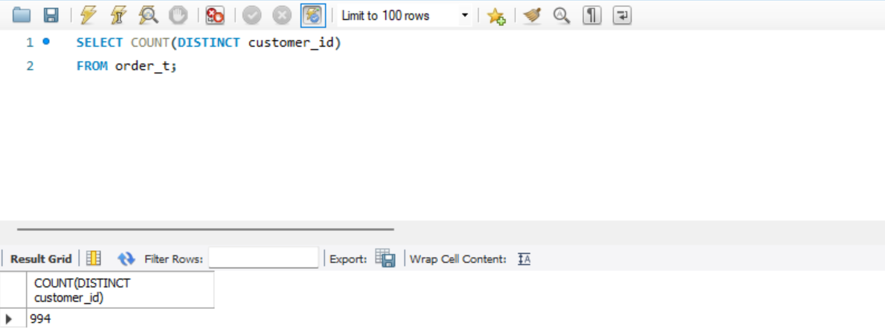

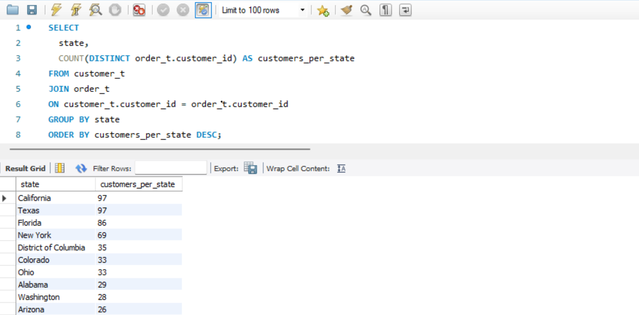

Observations and Insights:
- Texas and California have the highest customer count with 97 each
- Florida and New York follow closely behind, with 86 and 69 customers respectively, making them important secondary markets.
- Since Texas and California have the highest customer count, focus marketing efforts in those states.

Question 2: Which are the top 5 vehicle makers preferred by the customers?
Solution Query:
SELECT
vehicle_maker,
COUNT(*) AS total_orders
FROM order_t, product_t
WHERE order_t.product_id = Product_t.product_id
GROUP BY vehicle_maker
ORDER BY total_orders DESC
LIMIT 5;

Output:
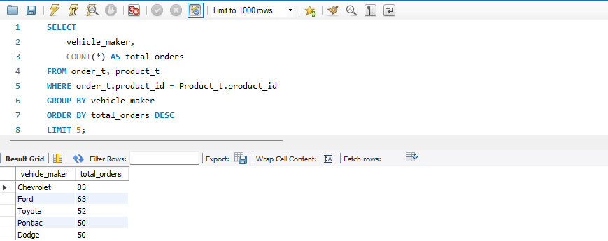

Observations and Insights:
- Chevrolets have the highest number of orders totaling 83, demonstrating strong customer preferences for this brand.
- Ford ranks second with 63 orders, indicating it’s also a popular choice among customers.
- The top five vehicle makers are mainly American brands, reflecting a strong preference for domestic manufacturers amongst customers.

Question 3: Which is the most preferred vehicle maker in each state?
Solution Query:
SELECT *
FROM (
SELECT
customer_t.state,
product_t.vehicle_maker,
COUNT(order_t.customer_id) AS total_orders,
RANK() OVER (
PARTITION BY customer_t.state
ORDER BY COUNT(order_t.customer_id) DESC)
FROM order_t
JOIN customer_t
ON order_t.customer_id = customer_t.customer_id
JOIN product_t
ON order_t.product_id = product_t.product_id
JOIN shipper_t
ON order_t.shipper_id = shipper_t.shipper_id
GROUP BY customer_t.state, product_t.vehicle_maker) AS ranked_makers
ORDER BY total_orders DESC;

Output:
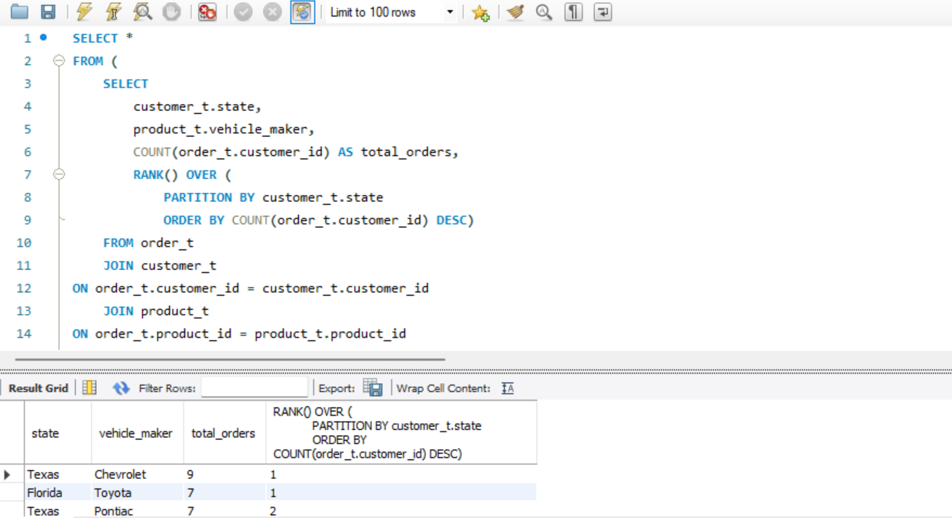
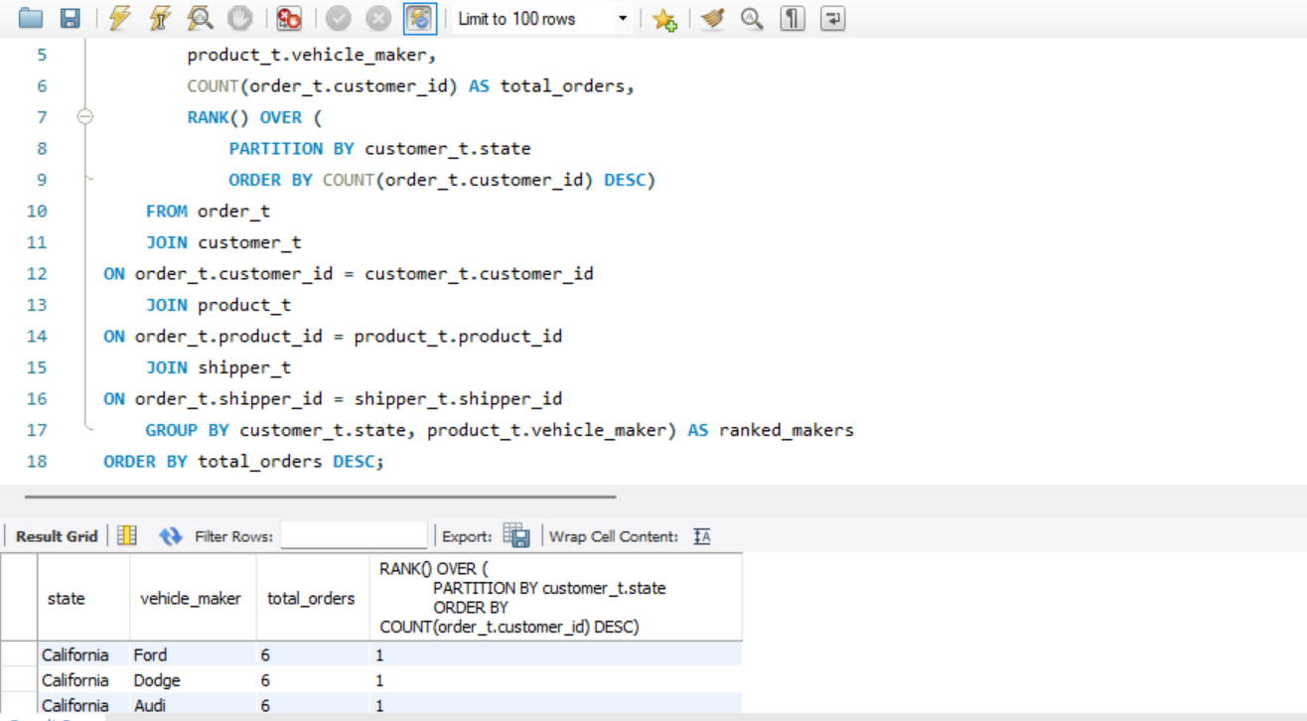
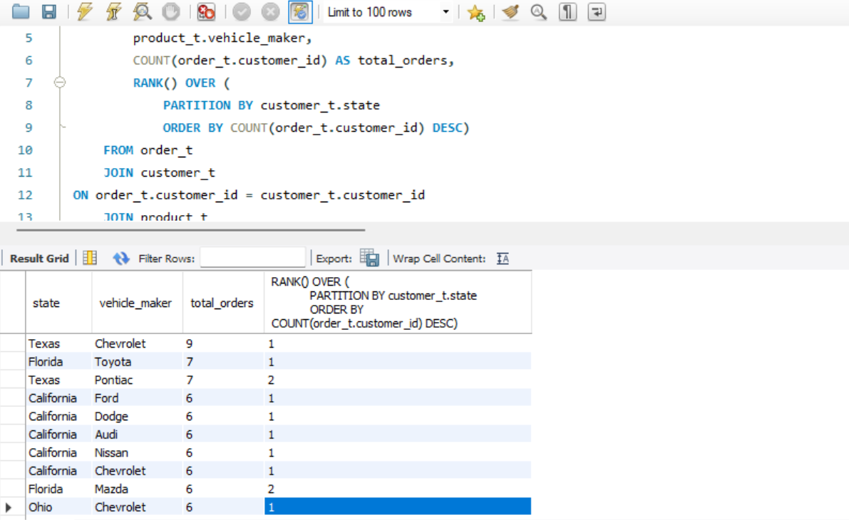

Observations and Insights:
- Chevrolets are the most preferred in multiple states including Texas and Ohio.
- Toyota leads in Florida indicating brand preference.
- California has multiple brands at the top with equal order counts indicating a highly competitive market with diverse customer preferences.

Question 4: Find the overall average rating given by the customers. What is the average rating in each quarter?

Consider the following mapping for ratings: “Very Bad”: 1, “Bad”: 2, “Okay”: 3, “Good”: 4, “Very Good”: 5
Solution Query:
----------overall average rating----------
SELECT
ROUND(AVG(
CASE customer_feedback
WHEN 'Very Bad' THEN 1
WHEN 'Bad' THEN 2
WHEN 'Okay' THEN 3
WHEN 'Good' THEN 4
WHEN 'Very Good' THEN 5
END), 2) AS overall_avg_rating
FROM order_t;

----------average rating in each quarter----------
SELECT
quarter_number,
ROUND(AVG(
CASE customer_feedback
WHEN 'Very Bad' THEN 1
WHEN 'Bad' THEN 2
WHEN 'Okay' THEN 3
WHEN 'Good' THEN 4
WHEN 'Very Good' THEN 5
END), 2) AS avg_rating
FROM order_t
GROUP BY quarter_number
ORDER BY quarter_number;

Output:
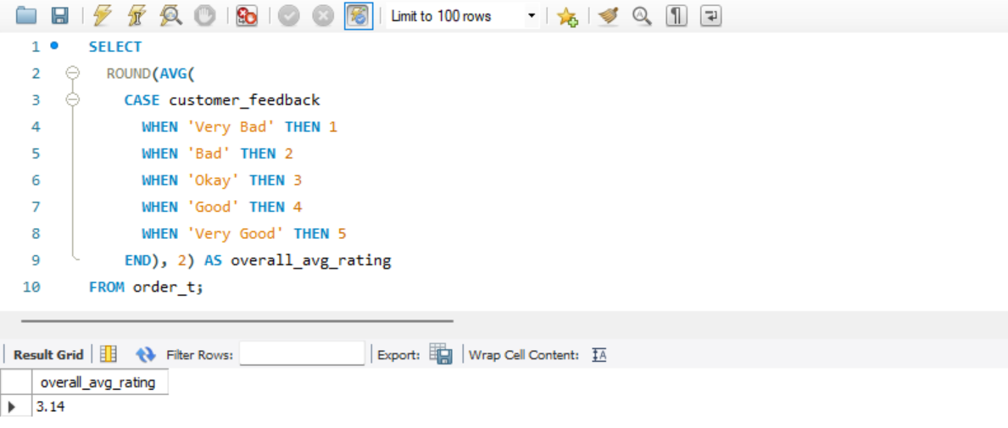
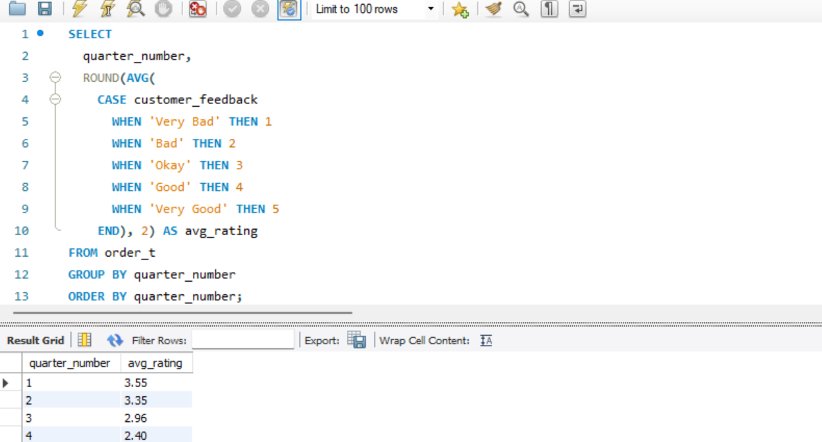

Observations and Insights:
- The average customer ratings show a clear decline as the year goes on. While satisfaction starts off strong in the early quarters, ratings gradually drop later in the year
- The highest average ratings are in the earlier quarters, which indicate stronger customer satisfaction at the beginning of the year.
- The lower ratings could be linked to external factors like shipping delays or supply chain disruptions.

Question 5: Find the percentage distribution of feedback from the customers. Are customers getting more dissatisfied over time?
Solution Query:
----------percent distribution----------
SELECT
customer_feedback,
ROUND(COUNT(*) * 100.0 / (SELECT COUNT(*) FROM order_t), 2) AS percentage
FROM order_t
GROUP BY customer_feedback
ORDER BY percentage DESC;

----------dissatisfaction----------
SELECT
quarter_number,
ROUND(COUNT(CASE WHEN customer_feedback IN ('Very Bad', 'Bad') THEN 1 END) * 100.0 / COUNT(*), 2) AS dissatisfied_percentage,
ROUND(COUNT(CASE WHEN customer_feedback IN ('Good', 'Very Good') THEN 1 END) * 100.0 / COUNT(*), 2) AS satisfied_percentage,
ROUND(COUNT(CASE WHEN customer_feedback = 'Okay' THEN 1 END) * 100.0 / COUNT(*), 2) AS neutral_percentage
FROM order_t
GROUP BY quarter_number
ORDER BY quarter_number;

Output:
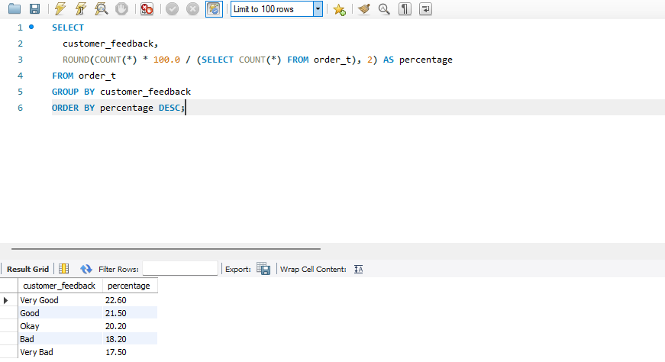
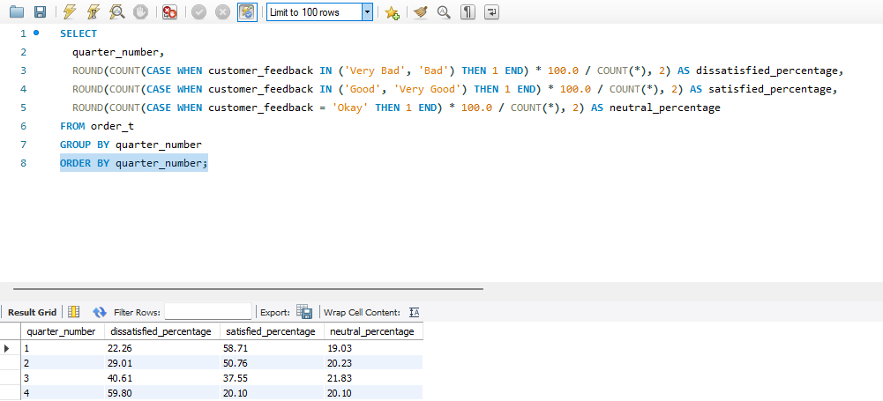

Observations and Insights:
- Each quarter has a blend of positive, neutral, and negative feedback, showing that customer experiences vary throughout the year
- The percentage of each feedback type changes from one quarter to the next, which suggests that customer satisfaction isn’t steady and may be affected by seasonal or operational factors
- There’s no clear upward or downward trend, but it’s clear that how customers feel changes as the year progresses

Question 6: What is the trend of the number of orders by quarter?
Solution Query:
SELECT
quarter_number,
COUNT(*) AS total_orders
FROM order_t
GROUP BY quarter_number
ORDER BY quarter_number;

Output:
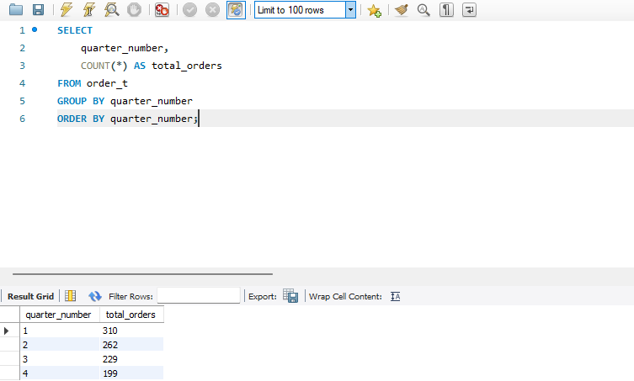

Observations and Insights:
- Customer interest or business activity slowed down over the year
- External factors could be the reason business activity has slowed down
- The last quarter has the lowest number of orders

Question 7: Calculate the net revenue generated by the company. What is the quarter-over-quarter % change in net revenue?
Solution Query:
SELECT
order_t.quarter_number,
ROUND(SUM(product_t.vehicle_price * order_t.quantity * (1 - order_t.discount)), 2) , ROUND((SUM(product_t.vehicle_price * order_t.quantity * (1 - order_t.discount))-LAG(SUM(product_t.vehicle_price * order_t.quantity * (1 - order_t.discount))) OVER (ORDER BY order_t.quarter_number)), 2)
FROM order_t
JOIN product_t
ON order_t.product_id = product_t.product_id
GROUP BY order_t.quarter_number
ORDER BY order_t.quarter_number;

Output:
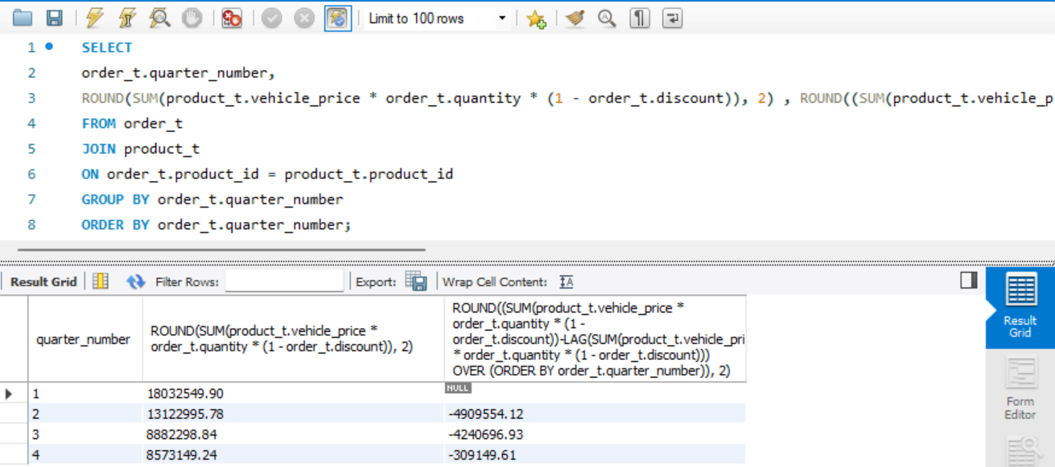

Observations and Insights:
- The company appears to be experiencing a consistent decline in the net revenue throughout the year.
- While net revenue declines quarter by quarter, the drop between quarter three and quarter four is smaller than between other quarters
- The revenue peaked in the first quarter but decreased in the following quarters.

Question 8: What is the trend of net revenue and orders by quarters?
Solution Query:
SELECT
quarter_number,
COUNT(DISTINCT order_id),
ROUND(SUM(product_t.vehicle_price * order_t.quantity * (1 - order_t.discount)), 2)
FROM order_t
JOIN product_t
ON order_t.product_id = product_t.product_id
GROUP BY quarter_number
ORDER BY quarter_number;

Output:
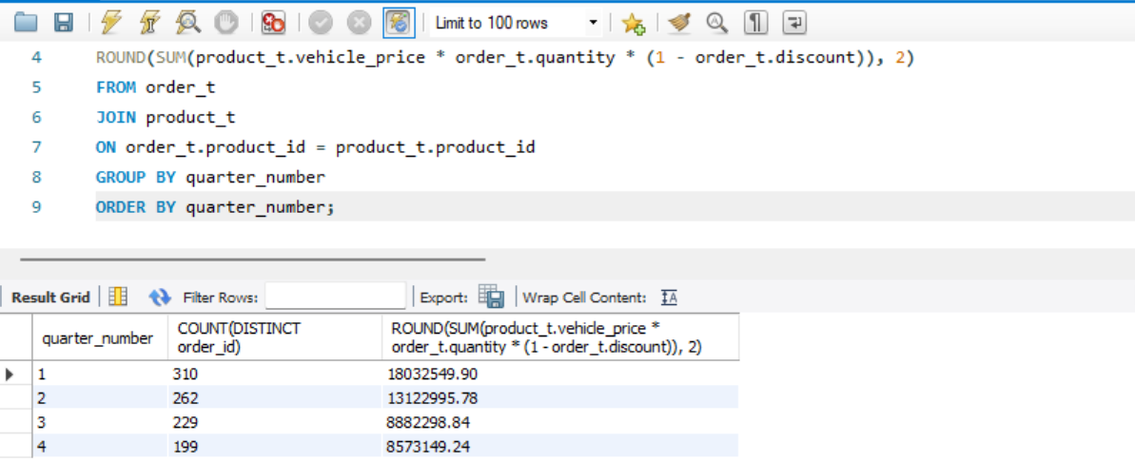

Observations and Insights:
- There’s a decline in both orders and revenue from quarter to quarter, suggesting a downward trend in business performance over the year.
- In the first quarter the highest revenue and order volume is shown, which shows the sales were initially strong.
- There is a drop in net revenue from the third quarter to the fourth quarter.

Question 9: What is the average discount offered for different types of credit cards?
Solution Query:
SELECT
customer_t.credit_card_type, ROUND(AVG(order_t.discount), 2) AS avg_discount
FROM order_t
JOIN customer_t
ON order_t.customer_id = customer_t.customer_id
GROUP BY customer_t.credit_card_type
ORDER BY avg_discount DESC;

Output:
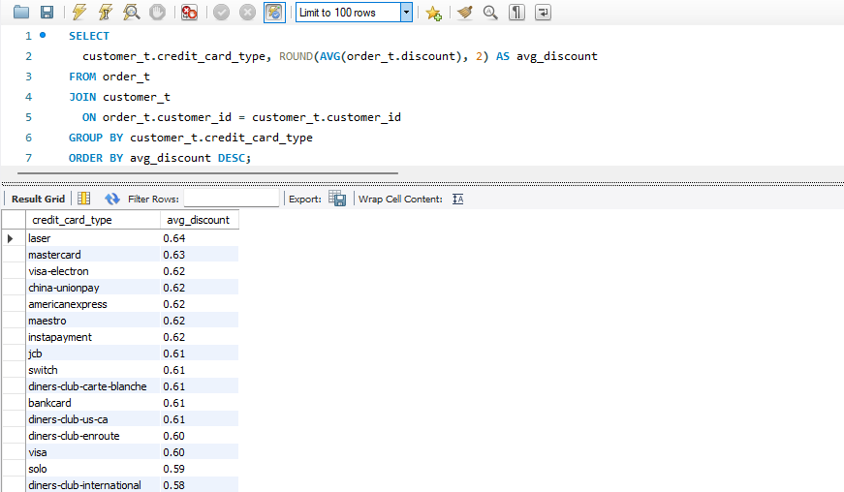

Observations and Insights:
- Some credit card types receive higher average discounts than others
- The average discount values vary from credit card to credit card, reflecting differences in how discounts are applied.
- The overall low discount percentages suggest the company offers modest discounts overall, which could impact the customers’ incentives.

Question 10: What is the average time taken to ship the placed orders for each quarter?
Solution Query:
SELECT
quarter_number,
ROUND(AVG(JULIANDAY(ship_date) - JULIANDAY(order_date)), 2) AS avg_shipping_days
FROM order_t
WHERE ship_date IS NOT NULL AND order_date IS NOT NULL
GROUP BY quarter_number
ORDER BY quarter_number;

----------Datediff----------

SELECT
quarter_number,
ROUND(AVG(DATEDIFF(ship_date, order_date)), 2) AS avg_shipping_days
FROM order_t
WHERE ship_date IS NOT NULL AND order_date IS NOT NULL
GROUP BY quarter_number

Output:

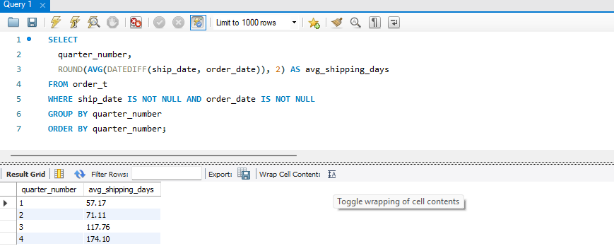

Business Metrics Overview
Total Revenue | Total Orders | Total Customers | Average Rating
48,610,993.78 | 1,000 | 994 | 3.14
Last Quarter Revenue | Last quarter Orders | Average Days to Ship | % Good Feedback
8,573,149.28 | 199 | 97.96 | 44.1

Business Recommendations
- Enhance the customers’ overall experience to boost satisfaction and loyalty.
- Improve coordination between ordering processing and shipment to achieve quicker turnaround times.
- Prioritize marketing efforts and inventory planning around the most in-demand vehicle makers to boost sales and meet customer demands.

